Task 14: Linux Server Hardening & Secure Configuration

1.Review default Linux system settings to understand users, services, and open ports.
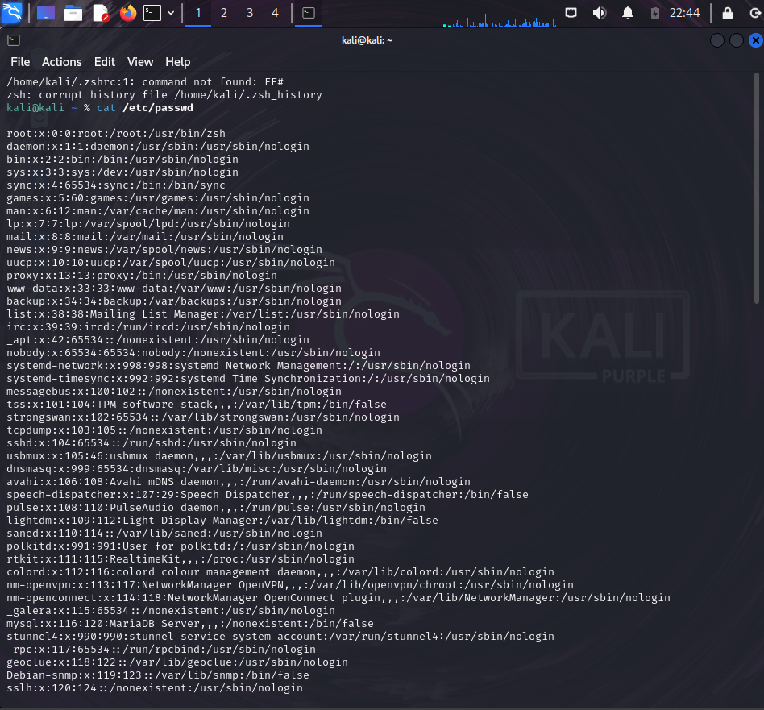
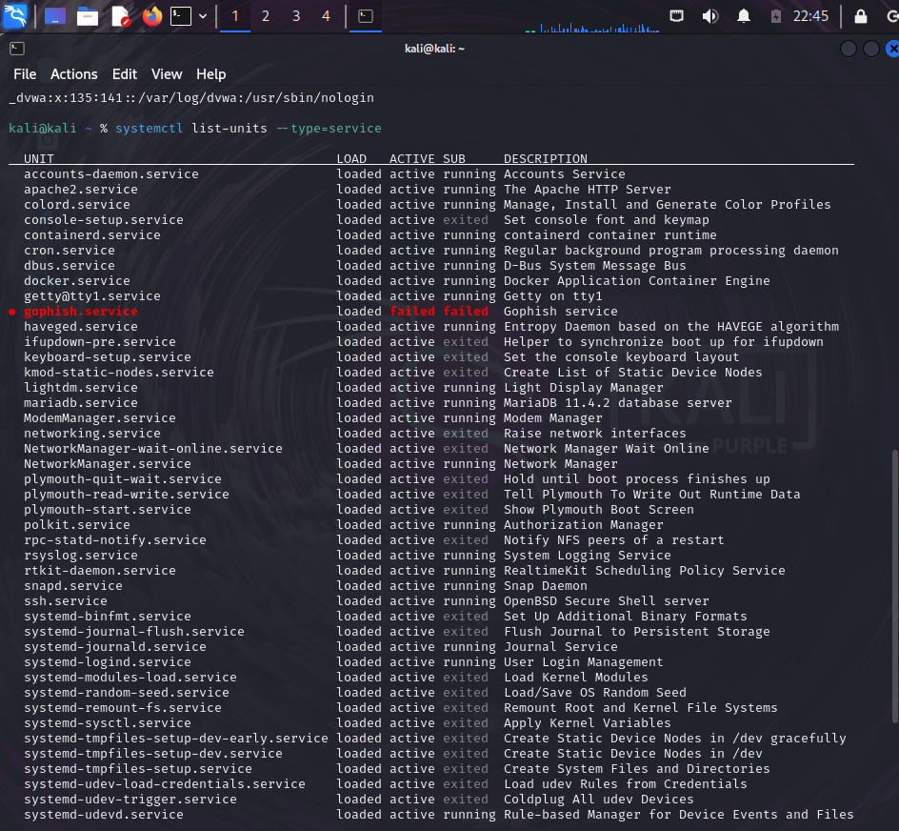
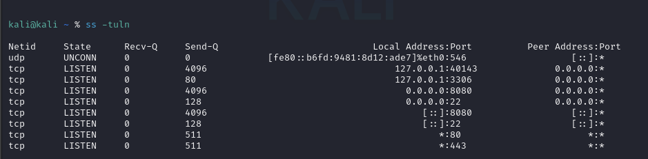

2.Remove unused user accounts and restrict sudo access based on least privilege
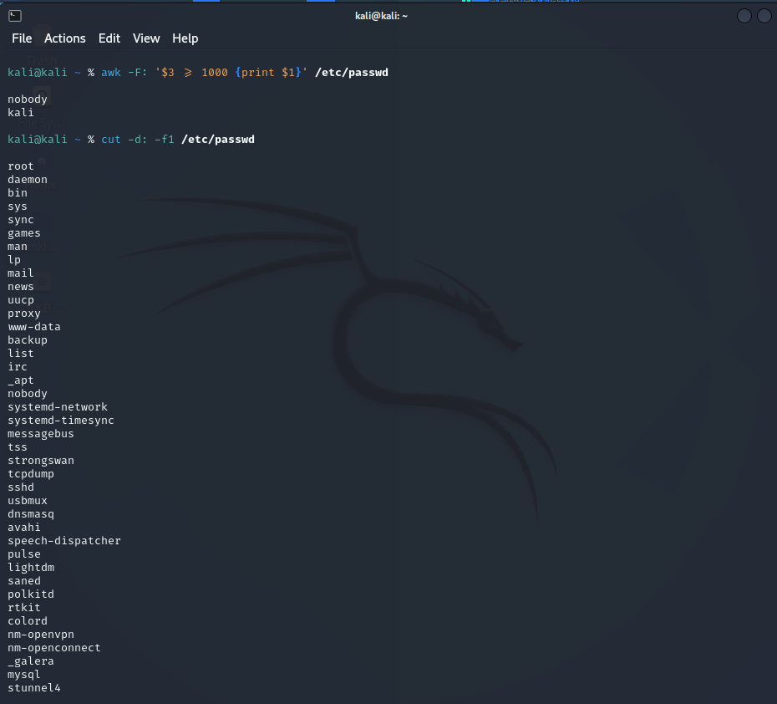
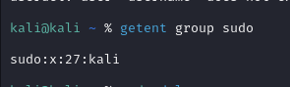

3.Disable root login and configure SSH using key-based authentication.
Part A: Disable Root Login via SSH
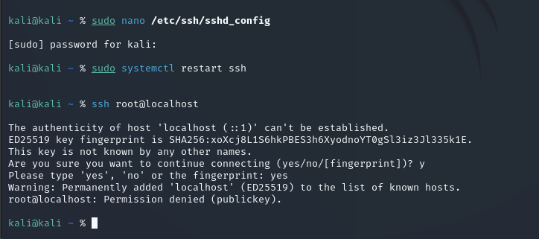
Part B: Configure SSH Key-Based Authentication
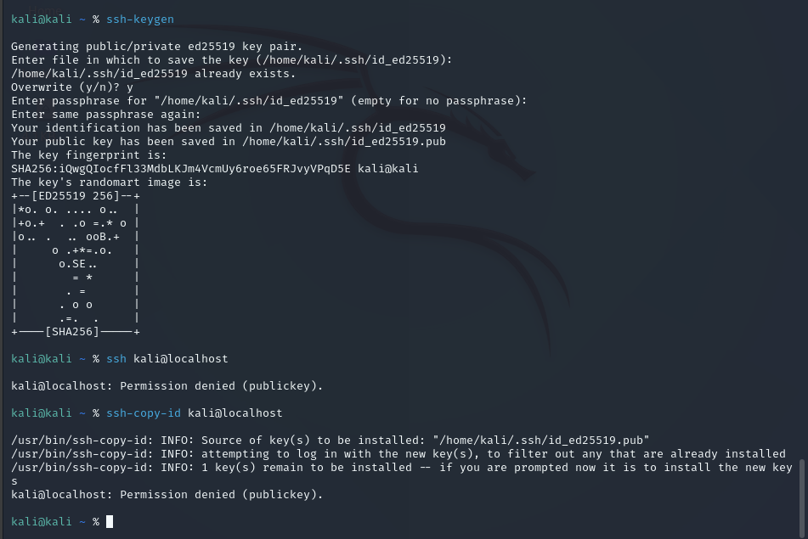
4.Update system packages and enable automatic security updates.
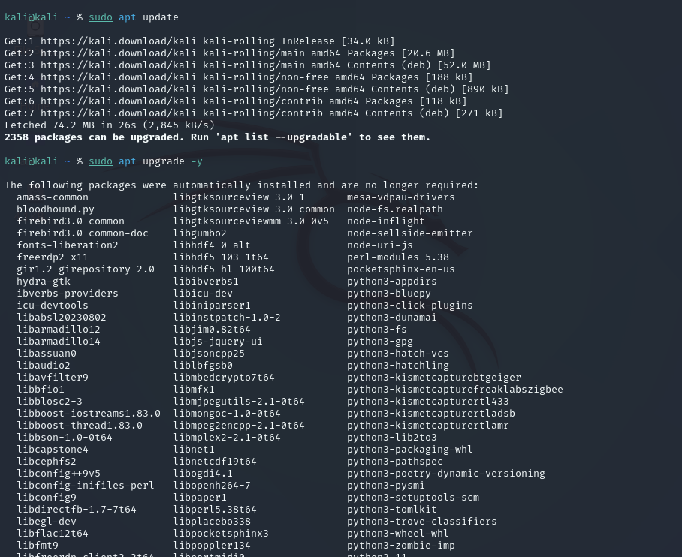

5.Configure a firewall to allow only required network traffic.
Step 5.1: Check if UFW is Installed
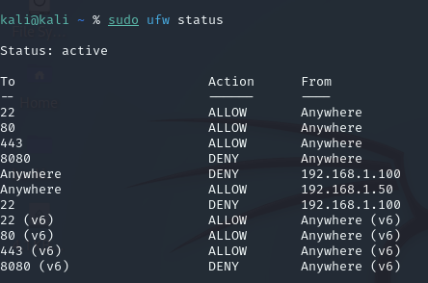
Step 5.2: Set Default Firewall Rules
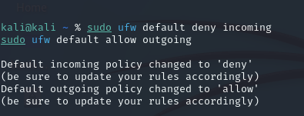
Step 5.3: Allow Required Services Only
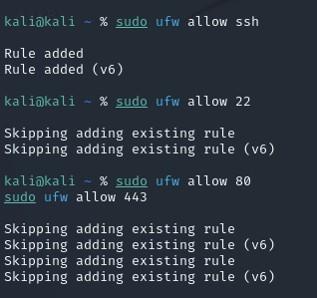
Step 5.4: Enable the Firewall
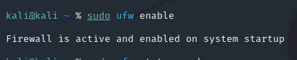
Step 5.5: Verify Firewall Status
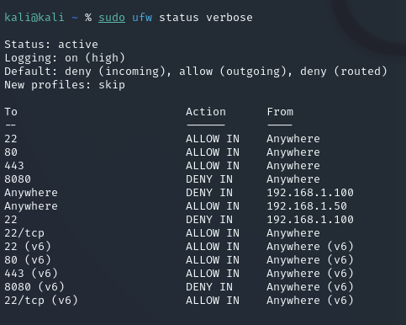

6.Stop and disable unnecessary services running on the server
List Running Services
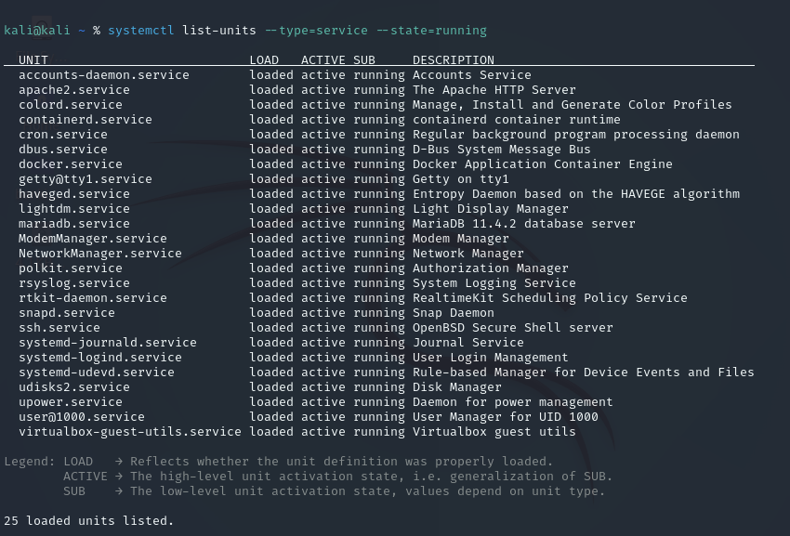
Stop,Disable and Verify Service Status
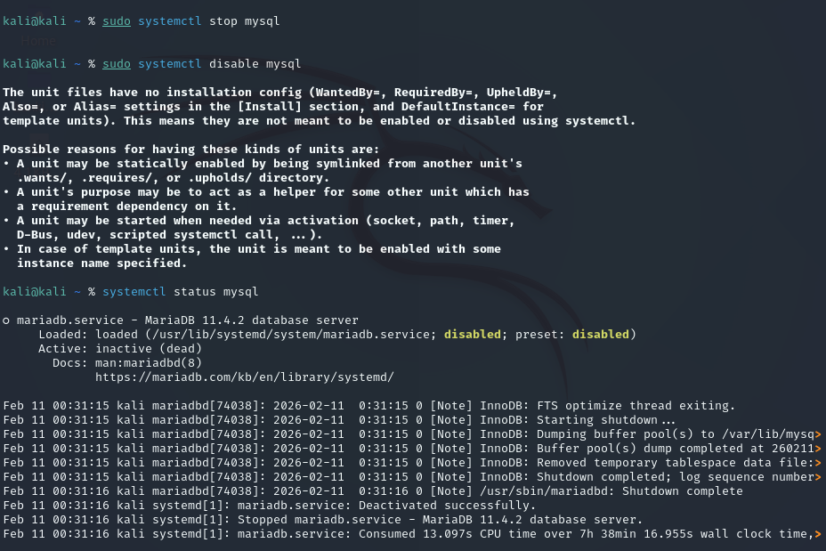
7.Secure file permissions for sensitive system and configuration files
Step 7.1: Identify Sensitive Files
Common sensitive files include:
- /etc/passwd → user account info
- /etc/shadow → encrypted passwords
- /etc/group → group info
- /etc/ssh/sshd_config → SSH configuration
- /etc/sudoers → sudo rules

Step 7.2: Check Current Permissions
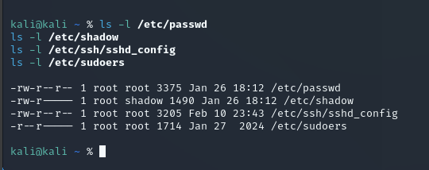

Step 7.3: Apply Secure Permissions
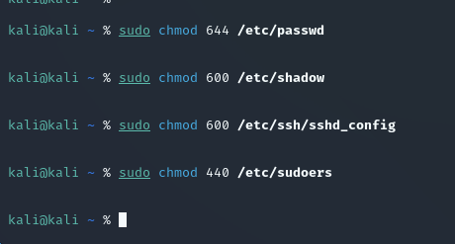

Step 7.4: Verify Permissions Again
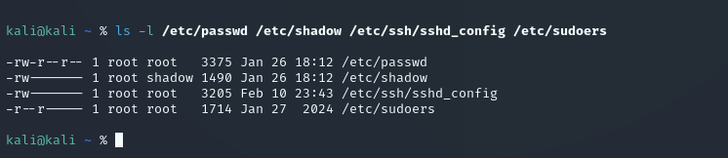

8.Review system logs to monitor authentication and system activity
Step 8.1: Review Authentication Logs
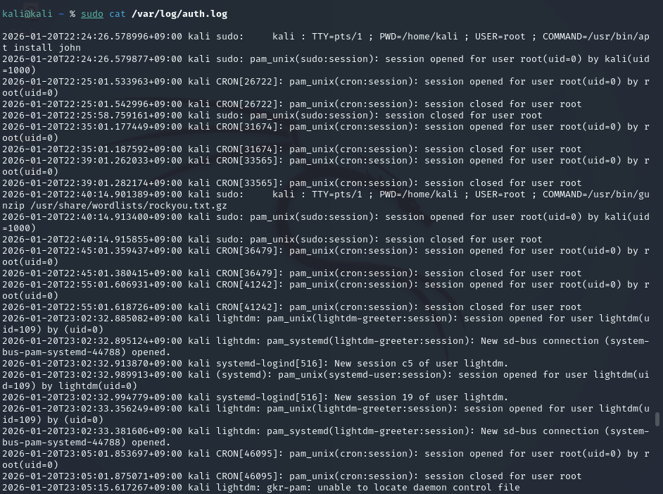
Step 8.2: Review General System Logs
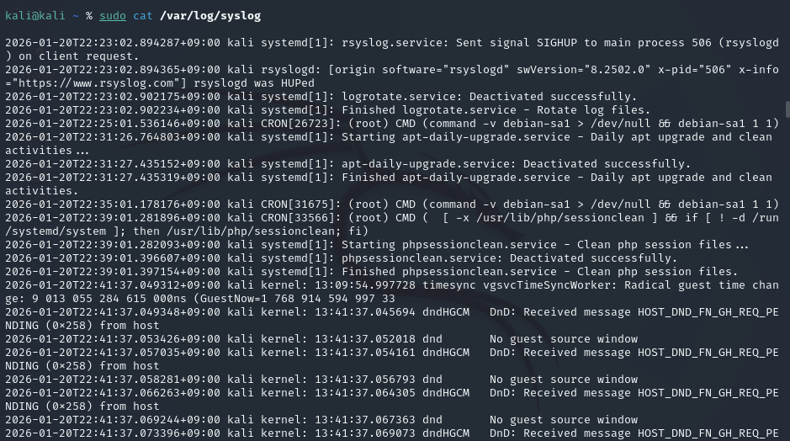
Step 8.3: Use Journal Logs
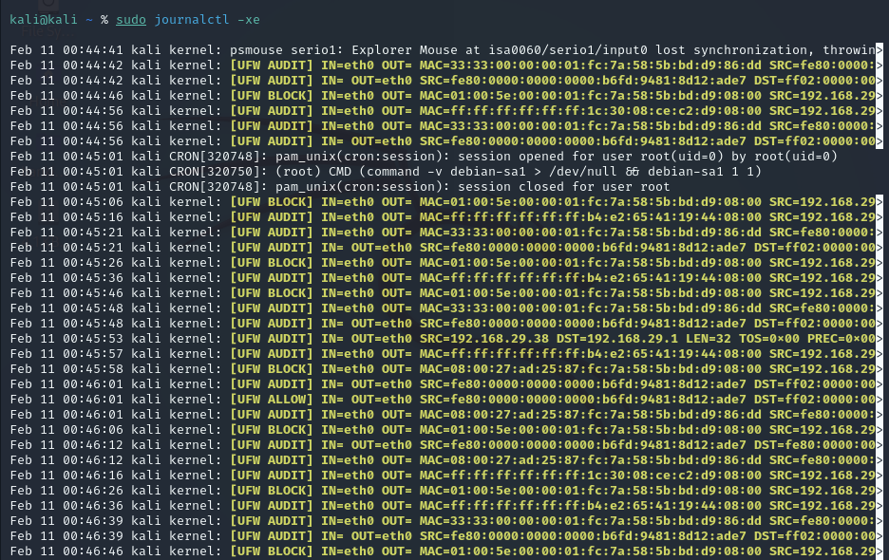

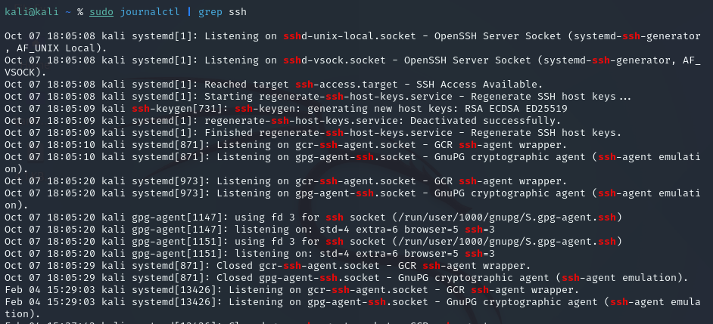

Conclusion
The Linux system was successfully hardened by reviewing user accounts, securing SSH access, applying system updates, configuring a firewall, disabling unnecessary services, enforcing strict file permissions, and monitoring system logs. These measures reduced the attack surface, enforced least privilege, and improved overall system security and stability.

